|  |  |
| --- | --- |
| NUIM_logo (Hi-Quality) | **National University of Ireland, Maynooth** Department of Electronic Engineering  EE204: Analog Electronics |

## Title: The Operational Amplifier

## Number: 5

**OBJECTIVE**

This lab will introduce you to the op-amp

### PROCEDURE

The circuit that you are using will be the LM741 op-amp, first introduced in 1968 by Fairchild Semiconductor. It has since been copied by many others. The pin-connection diagram for the 741 is shown below.

VCC is the positive voltage supply (+15 volts)

VEE is the negative voltage supply (-15 volts)

IN- is the MINUS input

IN+ is the PLUS input

OUTPUT is the output

The other pins do not need to be connected unless there is a problem

NC stands for no-connection.

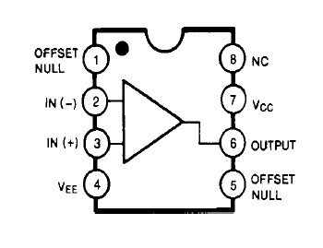

### PROCEDURE

**Part 1:**

Construct the following circuit.

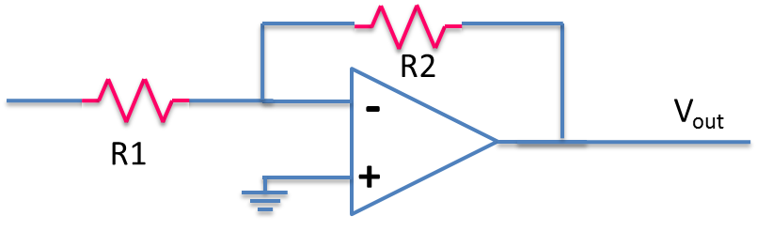

Construct the following circuit where both resistors are of value 1 kΩ. (Make sure you check with the demonstrators that your power supplies are correctly setup.)

Using a 10 kHz sine wave input, 1 Volt(peak-to-peak) with zero offset, compare the input to the output, both in magnitude and phase. Comment on what you observed.

Replace the resistor R2 with a 10 kΩ resistor. Comment on any change in the output.

**Part 2:**

Construct the following circuit, please note it’s a single 1 kΩ. resistor in addition to the previous circuit.

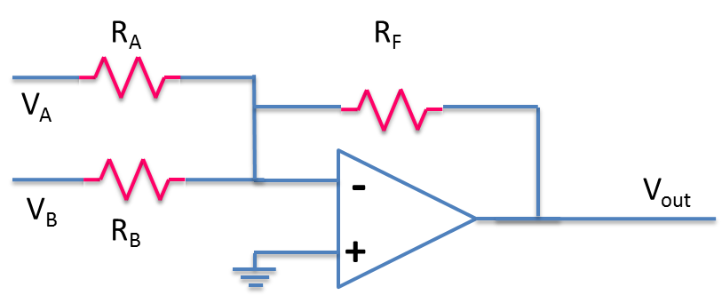

Use the same 10 kHz sine wave as the input for VA.

Use the constant voltage supply (5 Volts) for VB.

Comment on the resulting output voltage.

What is the name of this circuit you have just built?

**Part 3:**

Construct the following circuit.

Construct the following circuit where both resistors are of value 1 kΩ

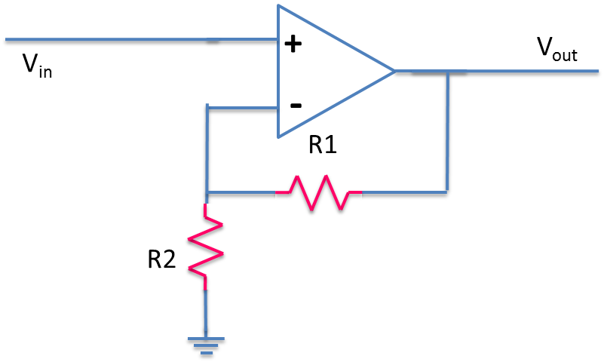

Using a 10 kHz sine wave input, 1 Volt(peak-to-peak) with zero offset, observe the output, both in magnitude and phase. Comment on what you observed.

Replace the resistor R1 with a 10 kΩ resistor. Comment on any change in the output.

Identify the value of resistor R1 that would yield a gain of 1 (input = output)

### REQUIRED RESULTS IN REPORT

* A brief introduction showing you know what the lab is about (3-4 lines MAX)
* For each section you need the following
  + - A drawing of the circuits used
    - Your results, including sketches or photographs of waveforms
    - Answer all questions asked
    - Comments and opinions on results or methods used
* Conclude your report with a summary section which may include any additional conclusions you may have.

|  |
| --- |
| **Marks will be deducted for poorly presentation, poorly written reports.**  **Marks will only be awarded for sections completed.** |